**Iterative development** is a design process commonly used by graphic designers and creative professionals. It helps to build and expand on a particular **concept** or idea.

**A CONCEPT is an abstract idea that lies at the heart of every effective design solution.**

**An ITERATION is a recreation or a new version of something.**

When applied to design, an iterative process involves repeatedly reproducing and refining ideas or concepts to ensure the best outcome. For a fine art artist, this could mean creating numerous sketches before arriving at the artwork that will be hung in a gallery. For a novelist, it involves creating numerous drafts before submitting a final manuscript for publishing. For a photographer, iteration is when the photographer takes a number of shots before one is selected for a magazine cover.



Fig 1. Unsplash (n.d.) Ideation includes discarding some ideas and keeping others

Designers understand that their first versions are generally not representative of their best or most effective work but they also realise that the first designs come from unbridled instinct and freedom of expression. As a result, they will go through an iterative development process to rework these first instincts into something more refined and to reconstruct certain elements to be the best and most effective they can be. This process allows for experimentation and a deeper understanding of the work, which in turn yields better, more successful and tailored results.

### Plan

Before embarking on the ideation phase, you should first put some time aside to plan. An iterative development process requires a clear contextual understanding of the design problem and its requirements. For the iterative process to be effective it first requires focus so that each iteration remains directed at creating a constructive concept or solution.

The planning phase is driven by research, whether primary or secondary, and should always relate to the design problem at hand. The starting point is outlining limitations such as budget constraints and deadlines. You then need to start some initial research. For example, if a brief states that you need to design something new, exploring the client’s competitors, trends, and other designs within a particular industry will inform your design and help inspire new and exciting ideas. If you are required to review or update a design for a client, analysing customer or stakeholder feedback is a good way to establish a framework from which to work.

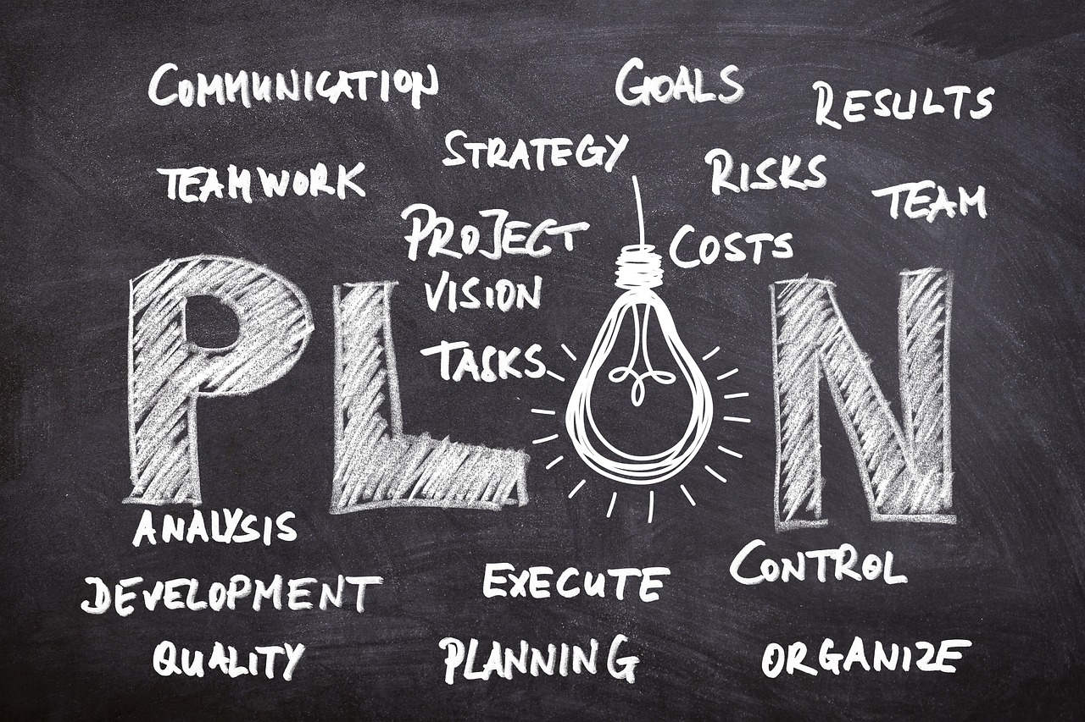

Fig 2. Pixabay (n.d.) Planning

Ultimately, you cannot enter the ideation phase without first educating yourself on the brief in detail. You need to have a clear and focused concept goal to help guide you during each step of the ideation phase which will also save you and your client time and resources in the long run.

### Ideation

During this stage of the iterative process, the aim is to generate as many ideas as possible, regardless of their quality. It is important to start by recording initial thoughts and ideas which can be done using a camera, a phone, or your sketchbook. If something grabs your attention, draw it, note it down, photograph it or file it away immediately. Not only will your drawing and research skills improve but over time you will build yourself a “catalogue of inspiration” that you can draw upon at any time in your career - especially when you are short on ideas.

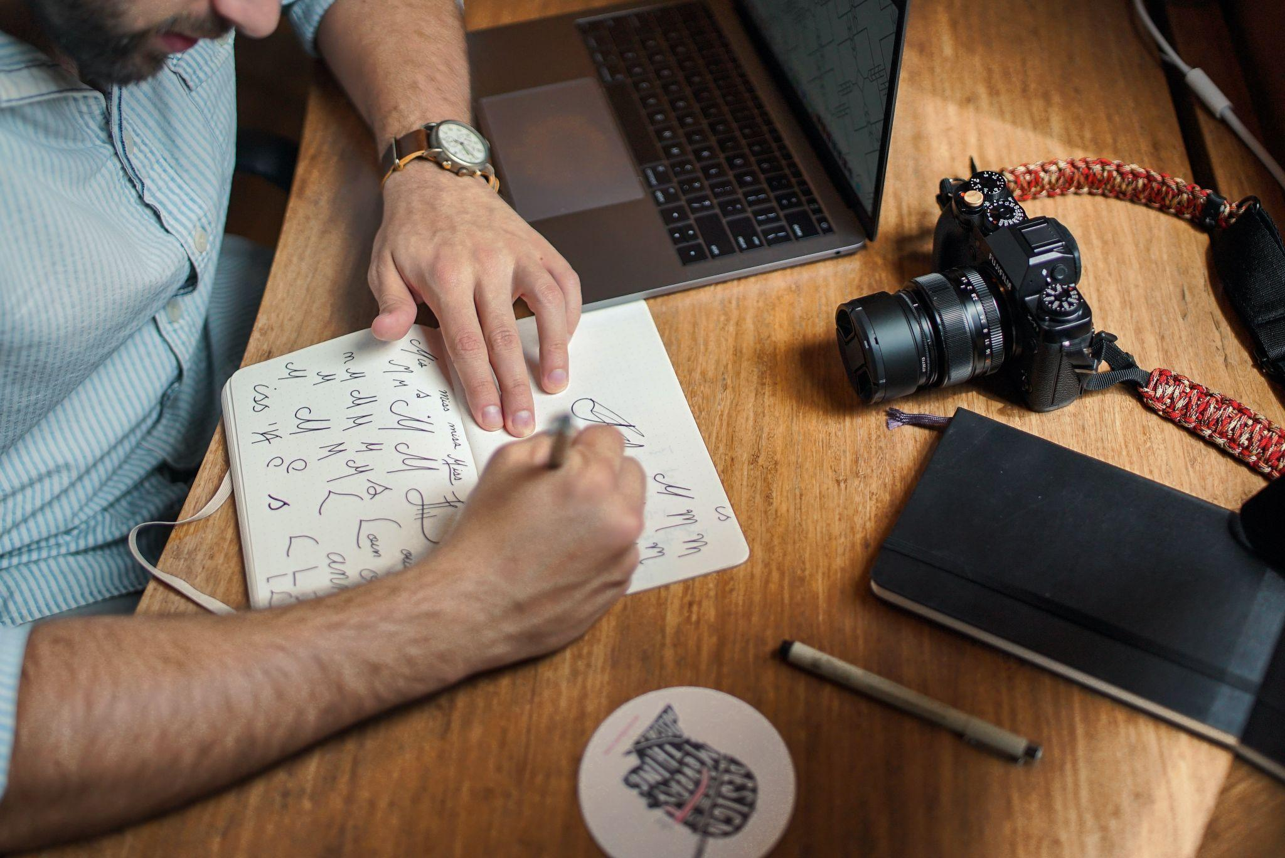

Fig 3. Unsplash (n.d.) Quick font experimentation

Sketching, although simple and traditional, is still one of the most prominent practices by professional graphic designers. It involves creating numerous rough drawings of possible design solutions and alternatives, and can include gridwork, tracing, colour palette testing, etc. Typically, designers make use of a pencil and paper for sketching, but this can also include drawing on a graphics tablet, depending on the designer's preference. 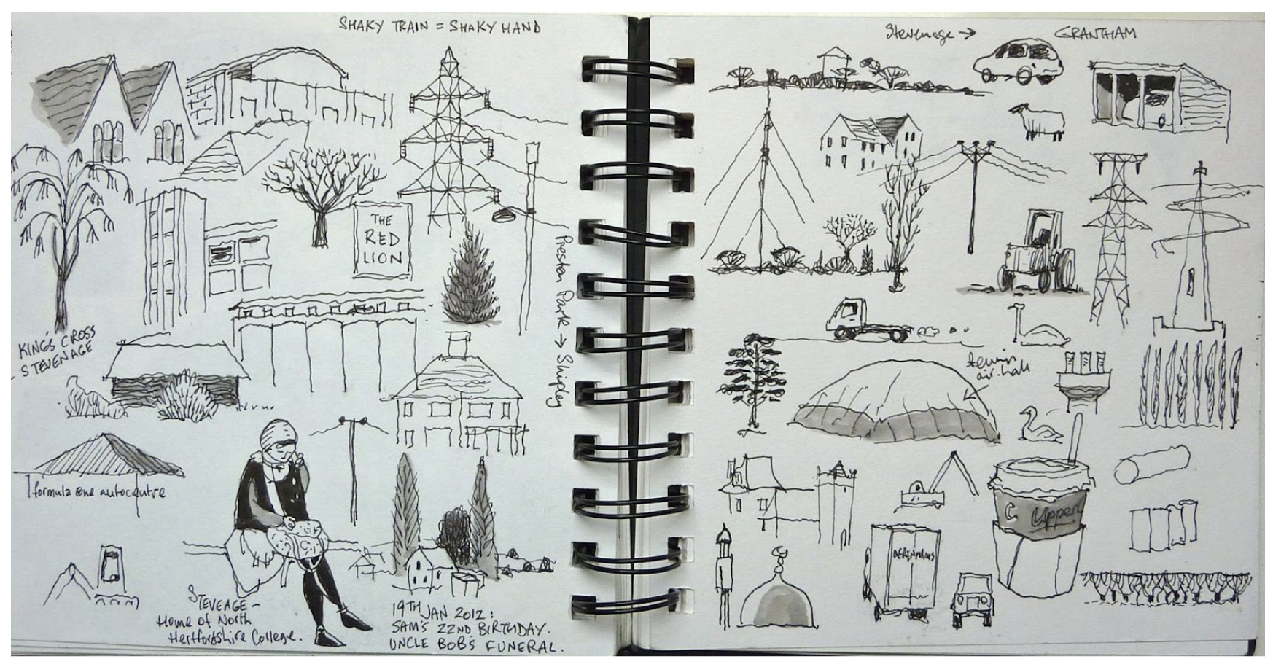

Fig 4. Recording ideas in a sketchbook

It is also a good idea to collect things that interest you. If you have for example, a love for old packaging, illustrated wrapping paper, material off-cuts or business cards, save them up and create scrapbooks. You never know when these might inspire or influence a project or brief.

Unlike written or verbal communication, sketches, photos, and other visuals can toy with the rules of grammar and can help clearly communicate ideas. This is especially valuable when working within a team. Sketching also keeps your creative juices flowing and can be quick, easy, and enjoyable, especially if you push yourself by adding challenging parameters.

There are several creative thinking methods that you can use, including:

* **Brainstorming:** Write down any idea that comes to mind but remove any critique. The goal is to jot down as many things as possible without spending much time thinking about any of them. They are just kernels of ideas that may or may not lead to anything.
* **Mind mapping:** Draw a web of thoughts, ideas, words and images that all stem from one central idea or word in diagram form, and then let it flow outwards organically. Mind mapping is a way to brainstorm in a more visual way by showing how different concepts are connected to each other.
* **Crazy 8s:** Create 8 concept sketches related to the design brief within 8 minutes.
* **8-4-2-1 Rapid Sketching:** Sketch for 8 minutes, then for 6 minutes, 4 minutes and finally 2 minutes, with 2 minute feedback sessions in between.
* **Positive/Negative:** Choose a simple object and instead of trying to draw the object, only draw the negative space around the object.
* **Mash Up or Forced Relationships:** Create doodles that are based on combining two unrelated concepts/objects to create a connection between them.
* **Fat Marker Sketches:** Begin by sketching ideas using only a fat marker to force simplicity, after which you move on to thin nibbed markers to add more and more detail.
* **Round Robin (team):** Each team member draws a solution to a design problem and passes it to another member. They then add to the drawing before passing it on again or they can give it back to the initial designer with feedback regarding the idea’s strengths and weaknesses.
* **Lateral thinking:** This involves looking at a design problem or challenge from different perspectives or unconventional angles. By thinking beyond the obvious and freeing up the imagination, ideas can spring from somewhere different to typical linear thinking patterns.
* **Simulation:** Simulation or role-play is where researchers or designers act out various scenarios, putting themselves in the shoes of the intended audience for a specific brand, product, or service. It helps designers better understand the customers, in order to create more effective graphic designs to attract and engage those viewers.
* **SCAMPER:** SCAMPER is an acronym for seven techniques that are typically used in teams. The keywords represent the necessary questions addressed during a creative thinking meeting:
  + (S) substitute,
  + (C) combine,
  + (A) adapt,
  + (M) modify,
  + (P) put to another use,
  + (E) eliminate and
  + (R) reverse.

Take an existing product or service, then go down the list and ask questions regarding each of the seven elements. Apply the questions to values, benefits, services, product attributes, etc. Look at the answers that you came up with and consider which are viable solutions that could be further refined into a new product or used to enhance/develop an existing one.

If you are working on a design idea that involves layout, you can also create layout sketches using tracing paper and/or grid paper. This method involves laying out all your design elements in a clean and structured way without having to use a ruler for measurements. Tracing paper is also very useful if you need to adjust your design. Redrawing a design from a basic layout, outline, or template will speed up the entire process of duplicating elements.

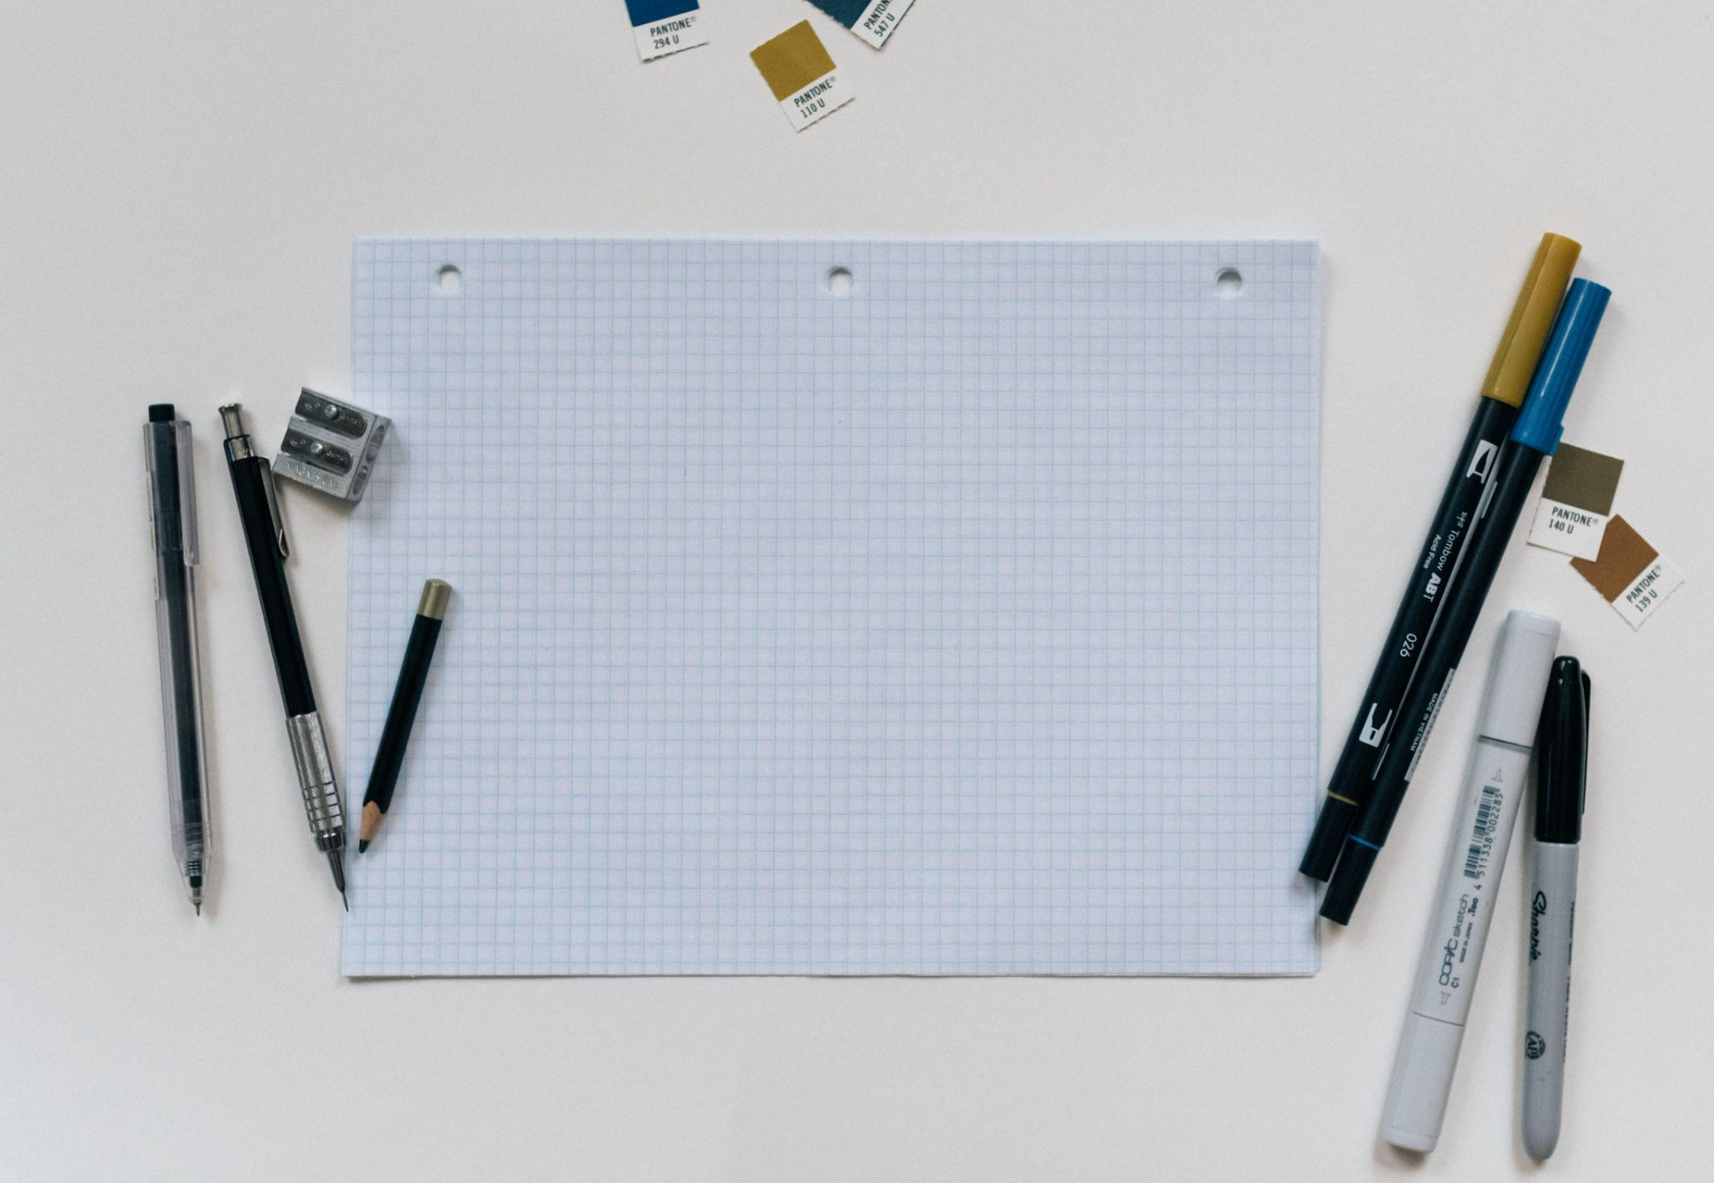

Fig 5. Unsplash (n.d.) Grid paper

### Refine Concepts

After you have created several sketches, it is time to assess what you have produced. This is where you need to take some time to evaluate and critique your conceptual ideas by comparing, contrasting and identifying their potential value. This will help you to refine them before presenting to clients and other stakeholders.

When looking at the concepts created via your idea generation process, consider the following:

* What are the pros, and what are the cons?
* What are the opportunities, and what are the limitations?
* What are the benefits, and what are the costs?
* Which element of the idea meets the brief more accurately?
* Which idea most accurately meets the brief?

Comparing the strengths and weaknesses of your various ideas will help you determine which ideas are worth exploring further and which ideas should be abandoned in the early stages. It is the idea generation process that gives you the opportunity to create a number of ideas that you can then evaluate to determine the best ideas you have to take further in the design process.

### Prototype

Now that you have a preferred design solution, focussing on a single concept should simplify the rest of the process. In some design industries, this would be a good time for you to move onto creating a prototype using CAD software. For example, in interior design, you would create your final floor plans in a digital format for presentation and/or sharing among installation team members. If your sketched idea is solid, transferring it to create a digital version can be very quick and easy.

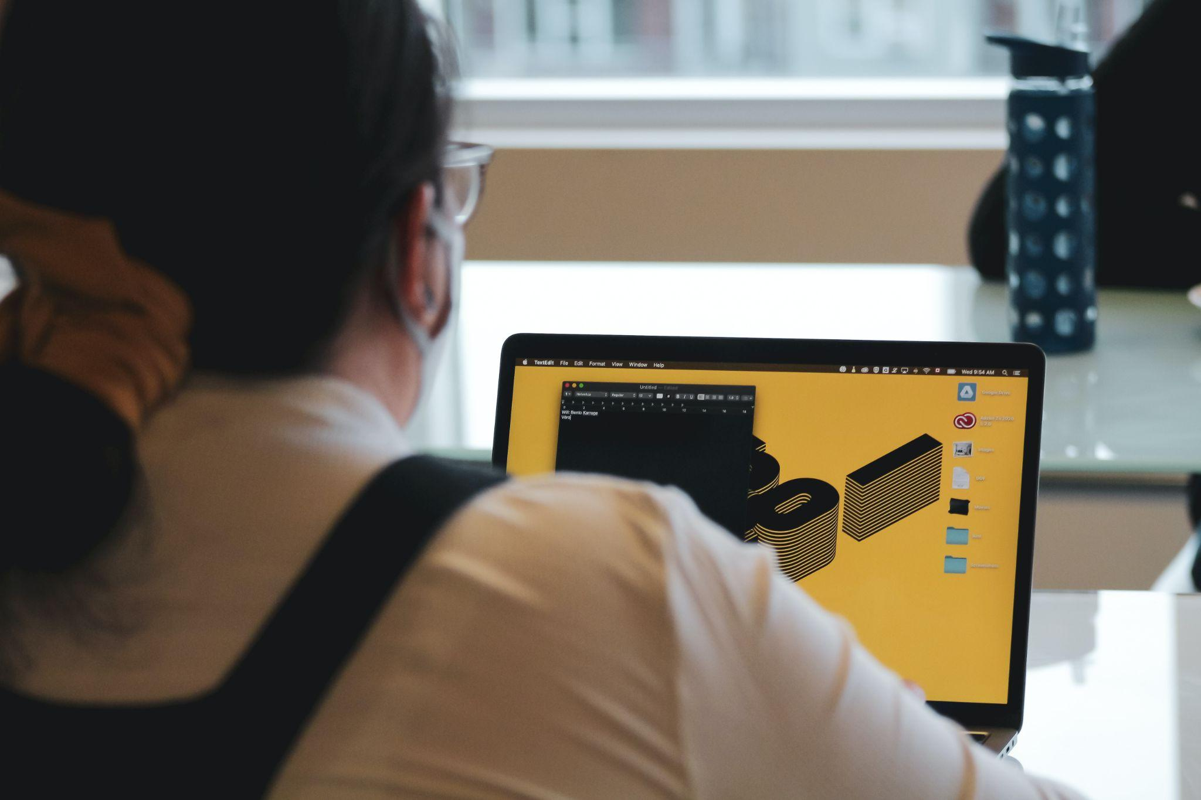

Fig 6. Unsplash (n.d.) Working with CAD

Creating a prototype or mock–up using CAD means that you can make small adjustments, but they should be minimal to avoid wasting more time on ideation rather than bringing the design to its final version.

In fashion design, you would create a toile as your prototype. This is the fitting version of a garment that's initially made up of inexpensive fabric so that the design can be tested on a model/user before creating the final line of clothing.

### Test & review

The objective of the testing stage is to find out whether or not the prototype solves the design problem or brief and to gauge how well it has worked. Now is not the time to implement anything new. It’s simply about rolling out your design to see if it effectively answers the brief.

For example, if you have a photograph that was taken for a particular marketing campaign, you could trial it with an audience who will view the image and can provide you with insights regarding their experience and this its impact. This helps you to objectively understand your design choices through feedback, findings, and insights. Depending on the design, other ways to gain feedback can be through a public survey or presenting to:

* a client
* colleagues/team members
* other creative practitioners
* a focus group.

After analysing the results, you can then come to a conclusion about the effectiveness of the design concept. 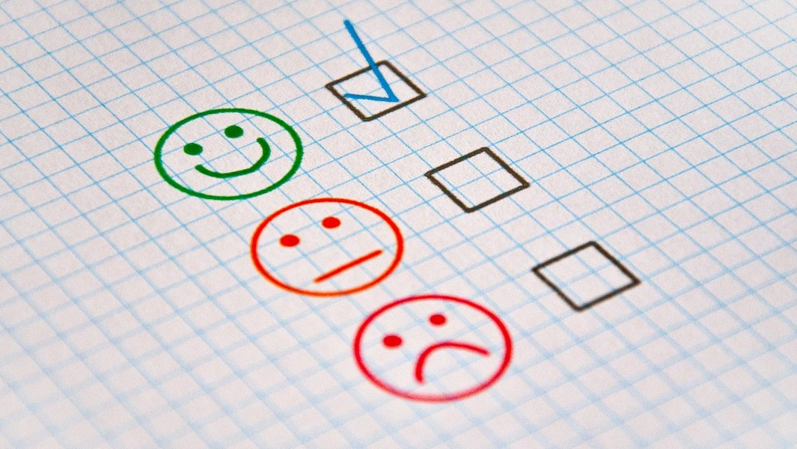

Fig. 7 Pixabay (n.d.) Success rating

A final conclusion typically falls into one of the following categories:

* The design is suitable, effective, and addresses the brief (i.e. ready for implementation)
* The design can be improved (i.e. needs minor adjustments to mock-up)
* The design does not satisfy the brief or solve the design problem (i.e. requires further or more extensive ideation)

If it’s the latter, you will then need to revisit the ideation stage and decide if the problem lies with the initial idea or if it was during later iterations.